**Super Market Sales Analysis**

**Abstract :**

This project presents an exploratory data analysis (EDA) of supermarket sales data using Python. The dataset, obtained from a real-world supermarket, was analyzed using the pandas library for data manipulation and matplotlib for visualizations. Bar charts were used to compare revenue across branches, line charts highlighted product line performance, and pie charts illustrated the distribution of payment methods. The project provides a visual and statistical understanding of the business, supporting data-driven decision-making in areas such as inventory, marketing, and customer engagement strategies.

**Coding </> :**

import pandas as pd  
import matplotlib.pyplot as plt  
import seaborn as sns  
df=pd.read_csv('supermarket_sales.csv')  
branch_sales = df.groupby('branch')['revenue'].sum()  
print("Branch Wise sales : ")  
print(branch_sales)  
products_count=df['product_line'].value_counts()  
print("products and its count")  
print(products_count)  
payment_methods = df['payment_method'].value_counts()  
print("payment methods and its count")  
print(payment_methods)  
#matplotlib  
#bar chart  
x=branch_sales.index  
y=branch_sales.values  
plt.bar(x,y,color='skyblue')  
plt.xlabel('Branch')  
plt.ylabel('Total Revenue')  
plt.title('Total Revenue by Branch')  
plt.show()  
#line chart  
plt.plot(products_count.index,products_count.values)  
plt.xlabel('Product Line')  
plt.ylabel('Total Revenue')  
plt.title('Total Revenue by Product Line')  
plt.show()  
#pie chart  
labels = payment_methods.index  
sizes = payment_methods.values  
plt.pie(sizes, labels=labels, autopct='%1.1f%%', startangle=140)  
plt.title('Payment Method Distribution')  
plt.axis('equal')  
plt.show()

**Output :**

**1)Branch Wise sales :**

**Branch Sum of sales**

A 106200.3705

B 106197.6720

C 110568.7065

**Result :** **Branch B** emerged as the top-performing location in terms of total revenue.

**2)** **products and its count :**

**product_line Count**

Fashion accessories 178

Food and beverages 174

Electronic accessories 170

Sports and travel 166

Home and lifestyle 160

Health and beauty 152

**Result : Food and Beverages** and **Health and Beauty** were among the most product lines.

**3)** **payment methods and its count :**

**payment_method Count**

Ewallet 345

Cash 344

Credit card 311

**Result :** The most commonly used **payment method** was identified, helping understand customer preferences.

**Charts :**

**BAR CHART**

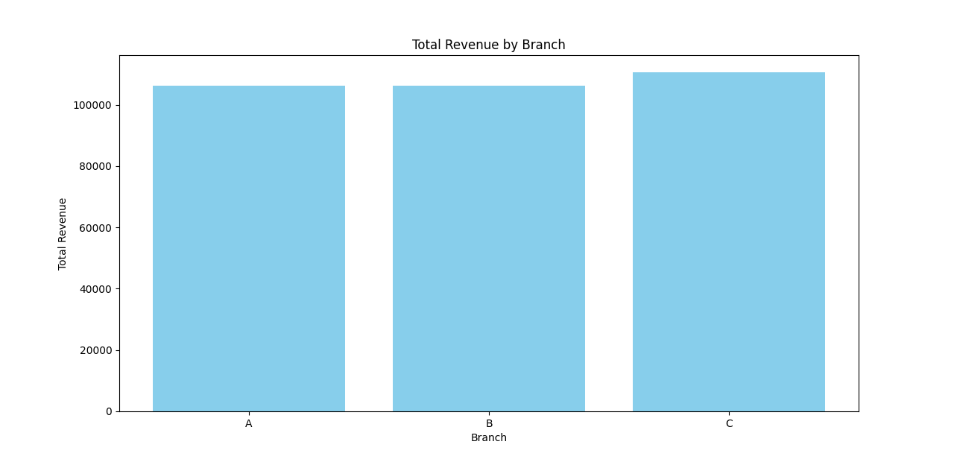

**Result :** The **bar chart** clearly showed differences in total revenue among branches, with **Branch B** standing out as the top earner.

**LINE CHART**

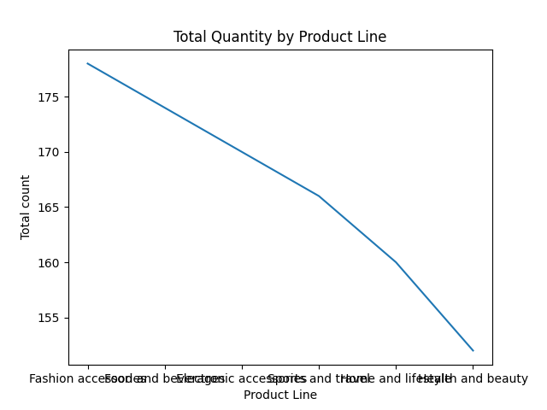

**Result :** The **line chart** illustrated how quantity varied across different **product lines**, revealing that certain categories such as **Food and Beverages**.

**PIE CHART**

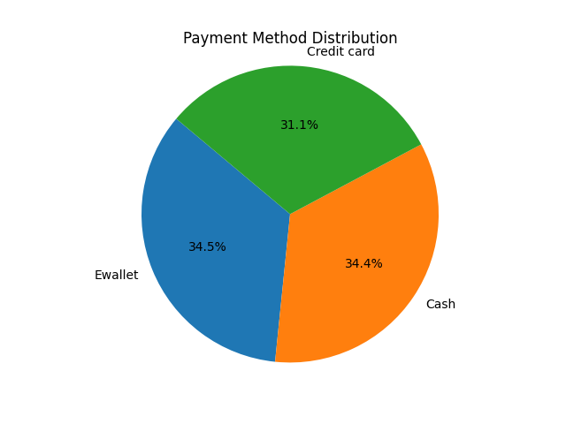

**Result :** The **pie chart** gave a clear view of **payment method distribution**, indicating customer preferences and aiding financial planning.

**Conclusion :**

This project successfully demonstrates how Python, along with libraries like pandas and matplotlib, can be used to perform an effective and insightful analysis of real-world supermarket sales data.

**Submitted by:**  
**M. Selvakumar**